2019 ROCK THE DESERT CAMPING/RV RULES AND REGULATIONS

- All campers must reserve a Camping Reservation or RV Reservations. Camping Reservations/RV Reservations can be made through the ticket link. All fees collected for camping/RVs are NON-REFUNDABLE.
  - Each Camping Reservation covers up to 20 campers and we charge by the number of campers. However, there is no limit the number of tents allowed per spot. Each camper under the reservation will receive a pass for the portable showers/restrooms. Please Check in at RV/Camping Check In upon arrival.
    - 1-20 campers = 1 Camping Reservation.
    - 21-40 campers = 2 Camping Reservations.
    - 41-60 campers = 3 Camping Reservations.
    - 61 or more campers = 4 Camping Reservations.
  - Each RV Reservation covers 1 RV. Each additional RV will need its own reservation.
    - Please let us know how many people will be in each RV so we can have passes for the portable showers/restrooms available to them. There is no additional cost for the amount of people staying in each RV. If there are campers in your group that are not staying in the RV, you will need to make a Camping Reservation for them, in addition to the RV Reservation. We do not have RV hook ups.
- Anyone who enters the RTD grounds must purchase an admission ticket/wristband for the festival. You must be wearing your wristband to enter the grounds, even for set-up. NO EXCEPTIONS!
- Only registered campers/groups will be allowed to camp on the RTD grounds. No pets are allowed on ANY OF THE RTD grounds.
- Groups must be accompanied by at least one person who is 21 years of age or older. Groups include: Church youth groups, families, college groups, and groups of friends. The exception is a group of adults (“adult” means 18 years of age or older). Adults and Leaders of Groups must provide a photo I.D. for verification of age upon check-in.
- The leader/sponsor/adult must camp with the group for the duration of the festival. Parents cannot sign up for a campsite unless they are staying at the site.
- All campsites will be assigned on a first come, first serve basis. You may set up at gate open time. Gates open at 3:30 PM Thursday, August 1st for set up. RTD Camping Team Leader will assist you in making sure you have adequate space. You must tear down Sunday morning or before. Groups that do not arrive by 3:30 PM Thursday, August 1st, will be allowed to set up when they arrive.
- There are portable shower/restroom facilities on the RTD grounds. Use of these will be on a first come first serve basis as they can only serve a number of people at a time. The only restroom facilities available are porta potties.
- There are no open flames allowed on the RTD grounds. You may bring ice chests with drinks and food. NO GLASS OR ALCOHOL ALLOWED.
- Only tents will be allowed in the camping area. RV’s or pop up campers must park in the designated parking area. They must be self-contained as there are no hook ups on the grounds. Generators maybe used but they have to be placed off the ground, to prevent accidental fires. Once you arrive there will be a designated area for you to pull up and unload your equipment. This is not a permanent parking area, UNLOAD ONLY. You must then park your vehicle in a designated area. All cars left in the unloading area will be towed at the owner’s expense.
- Please respect the campers around you and adhere to the 1:30 AM quiet time in the camping areas.
- All campers (this includes people under RV Registrations too) must enter the festival each time through the RTD MAIN TICKET GATE, as show below. Any camper found entering the festival field through any other entrances will be asked to leave the property.
- All rules will be enforced by uniformed security.
- Rock the Desert is not responsible for theft or loss of personal property.

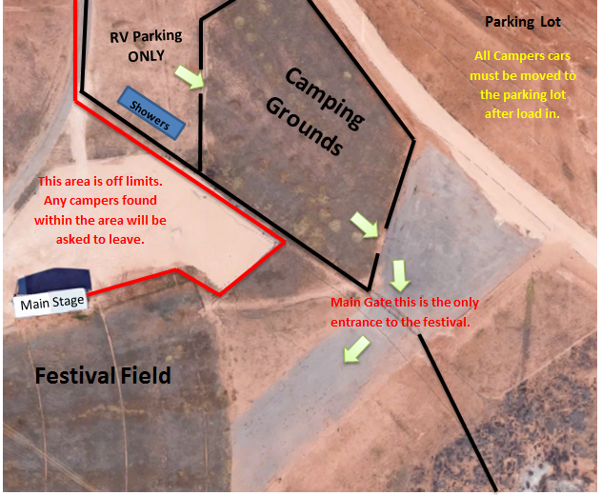

Main Stage
Main Gate this is the only entrance to the festival.
Festival Field

