The Ladies of Duck Dynasty

Benefitting

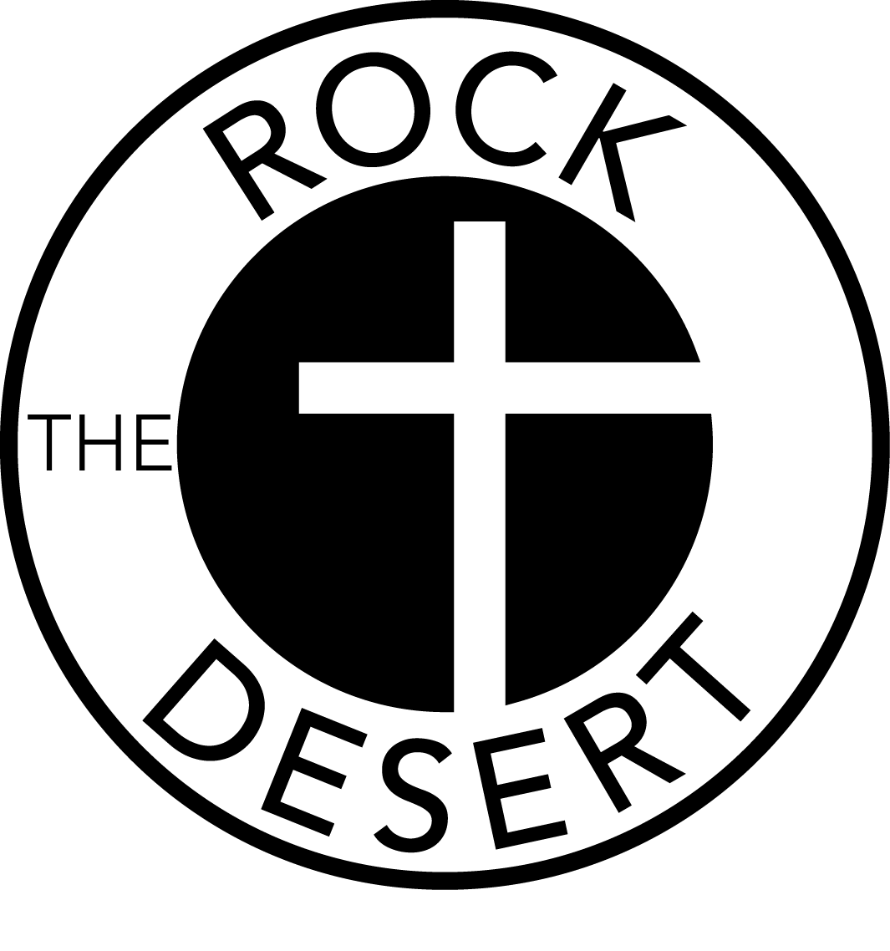

TABLE SPONSOR LEVELS

____$25,000.00 SINGLE-REED CALL Premier Table For 10
Meet/Greet/Photo Op with the Ladies of Duck Dynasty &
Sponsor Gift

____$10,000.00 DOUBLE-REED CALL Premier Table For 8
Meet/Greet/Photo Op with the Ladies of Duck Dynasty &
Sponsor Gift

____$5,000.00 HIGH BALL CALL Premier Table For 8 & Sponsor Gift

____$2,500.00 GREETING CALL Preferred Table For 8 & Sponsor Gift

____$1,500.00 LONESOME HEN CALL Preferred Table For 8 & Sponsor Gift

____$750.00 TRIPLE REED CALL Preferred ½ Table For 4

____$200.00 INDIVIDUAL TICKET 1 Reserved Seat at Table for 8

____Sorry, I cannot attend, but enclosed is a donation $_______

Sponsor Name________________________________________________________
As you wish to be recognized in the Program

Contact Person________________________________________________________

Phone__________________________Email_________________________________

Address______________________________________________________________

_____I will invite guests to fill my seats.
Please respond with your guest list when available.

_____I will not use my seats.
The entire amount of your sponsorship is a tax-deductible donation.

Please reply by
For payments by check, enclose your Sponsor form and payment in the reply envelope enclosed.

For credit card payments, visit our website at www.rockthedesert.com
And click on the “Reserve Table Now” button.

If you need additional information, please call Allison Tull or Brittany Brewer at 432-563-3434 or email to info@rockthesert.com

