The Ladies of Duck Dynasty
Benefitting

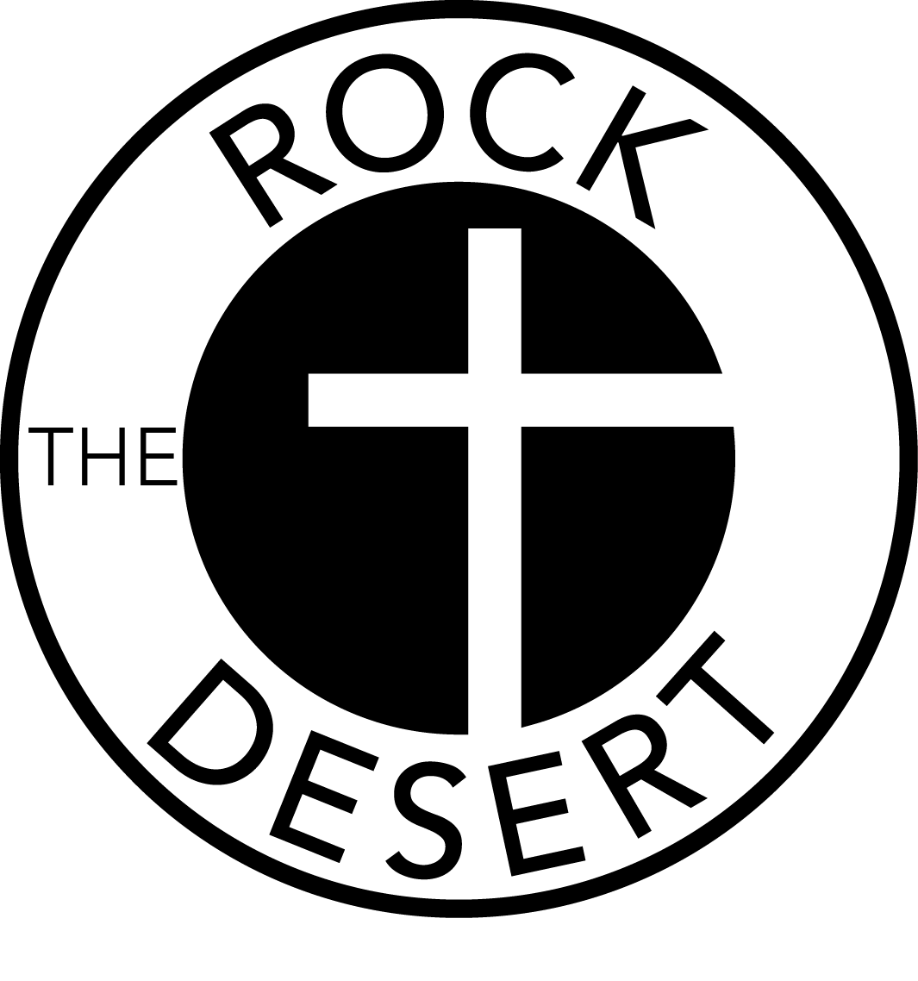

In August, Rock the Desert Ministries will present its 19th annual festival and we are excited to announce a new event added to the festival week. In addition to the worship service and the festival, we are featuring a luncheon with some very special guests on July 31, 2018.
Rock the Desert is pleased to bring the Ladies of Duck Dynasty – Miss Kay, Korie, and Missy Robertson to Midland Country Club for a luncheon and speaking engagement. The Ladies will present a multi-generational and inspiring perspective on faith, the appreciation of family, family values, and overcoming the family challenges of the 21st century. They will also participate in a question and answer session hosted by Kris Moore of the Morning Drive talk radio program. All of the SINGLE-REED CALL and DOUBLE-REED CALL Sponsors and their guests will have the opportunity to participate in a meet & greet and a professional photo opportunity with the Ladies of Duck Dynasty before the Luncheon. The first three SINGLE-REED CALL and/or DOUBLE-REED CALL Sponsorships received at any of those levels will have the opportunity to host one of the Ladies of Duck Dynasty as a guest at your table for the luncheon. Proceeds from this special event will fund Rock the Desert community outreach programs and help us keep the festival tickets at an affordable price for all to attend. There will also be a silent auction with some very special items that you may bid on during the Luncheon.
We are so excited to bring words of encouragement to the ladies of the Permian Basin by presenting the Ladies of Duck Dynasty. We are sure you will be blessed and inspired. We ask you to consider sponsoring this very special event at one of the Sponsorship levels listed below.
We are truly excited about this new event and we hope that you will consider sponsoring. Please let us know if you have any questions.

